Daniel Alzona
Polytechnic University of the Philippines
WhatsNext Vision Motors: Shaping the Future of Mobility with Innovation and Excellence

ABSTRACT
This project showcases the development and deployment of a customized Salesforce CRM solution for WhatsNext Vision Motors, a forward-thinking automotive company focused on innovation and customer-centric mobility solutions. The main objective of the project was to streamline business processes, enhance sales and project management efficiency, and maintain accurate and centralized data across departments.
The solution includes the creation of multiple custom objects, including Vehicle__c, Vehicle_Dealer__c, Vehicle_Customer__c, Vehicle_Order__c, Vehicle_Test_Drive__c, and Vehicle_Service_Request__c to manage vehicle inventory, dealer assignments, customer orders, and service requests. Key business processes were automated using Record-Triggered Flows, Scheduled Flows, Email Alerts, and Apex triggers, enabling automatic notifications for new vehicle orders, test drive schedules, and service requests.
Validation rules were applied to ensure data accuracy, and a role-based security model was implemented for Admin, Sales, and Project Management teams. Scheduled Apex batch jobs were also configured to automatically update vehicle availability and track order status.

OBJECTIVE
The primary objective of this project is to design and implement a customized Salesforce CRM solution for WhatsNext Vision Motors that:
- Automates essential business processes including vehicle order assignment, stock validation, test drive scheduling, and service request tracking.
- Ensures accurate and reliable data entry through validation rules.
- Provides real-time visibility into vehicles, customer orders, test drives, and service requests.
- Strengthens cross-departmental coordination using structured role-based access control.

PROJECT PHASES
Phase 1: Architecture & Planning
Custom Object Creation
Six main custom objects were created to store business-critical data:
Object Name | Purpose | Relationships
Vehicle__c | Stores vehicle details | Related to Dealer & Orders
Vehicle_Dealer__c | Stores authorized dealer info | Related to Orders
Vehicle_Customer__c | Stores customer details | Related to Orders & Test Drives
Vehicle_Order__c | Tracks vehicle purchases | Related to Customer & Vehicle
Vehicle_Test_Drive__c | Tracks test drive bookings | Related to Customer & Vehicle
Vehicle_Service_Request__c | Tracks vehicle servicing requests | Related to Customer & Vehicle
Steps Followed:
- Navigated to Setup → Object Manager → Create → Custom Object.
- Provided Label, Object Name, and enabled Reports/Search.
- Created Tabs for each object for easier navigation.
Data Management – Tabs
- Tab – Vehicle__c
- Tab – Vehicle_Dealer__c
- Tab – Vehicle_Customer__c
- Tab – Vehicle_Order__c
- Tab – Vehicle_Test_Drive__c
- Tab – Vehicle_Service_Request__c
Screenshot: Tabs created for all custom objects
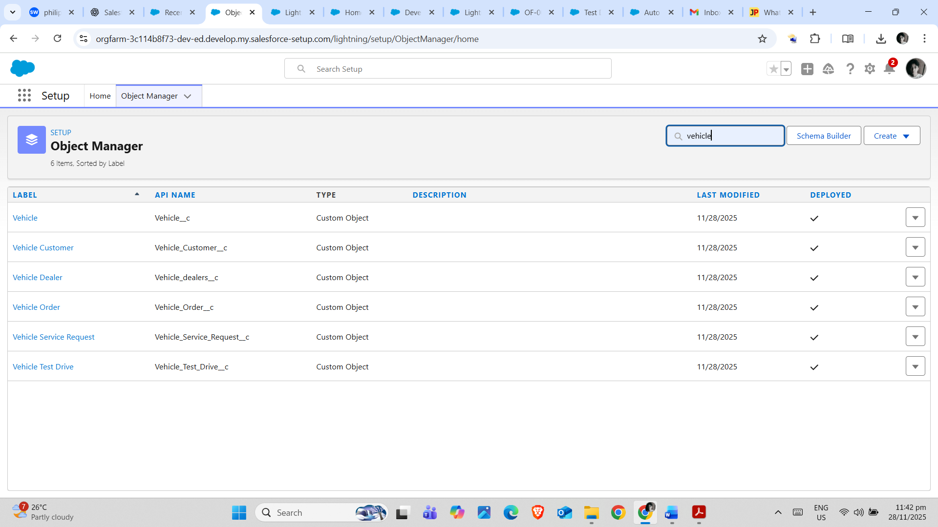
Data Management – Fields
Custom fields and lookup/master-detail relationships were created for each object:
- Vehicle__c: Vehicle Name, Model, Category, Price, Availability Status
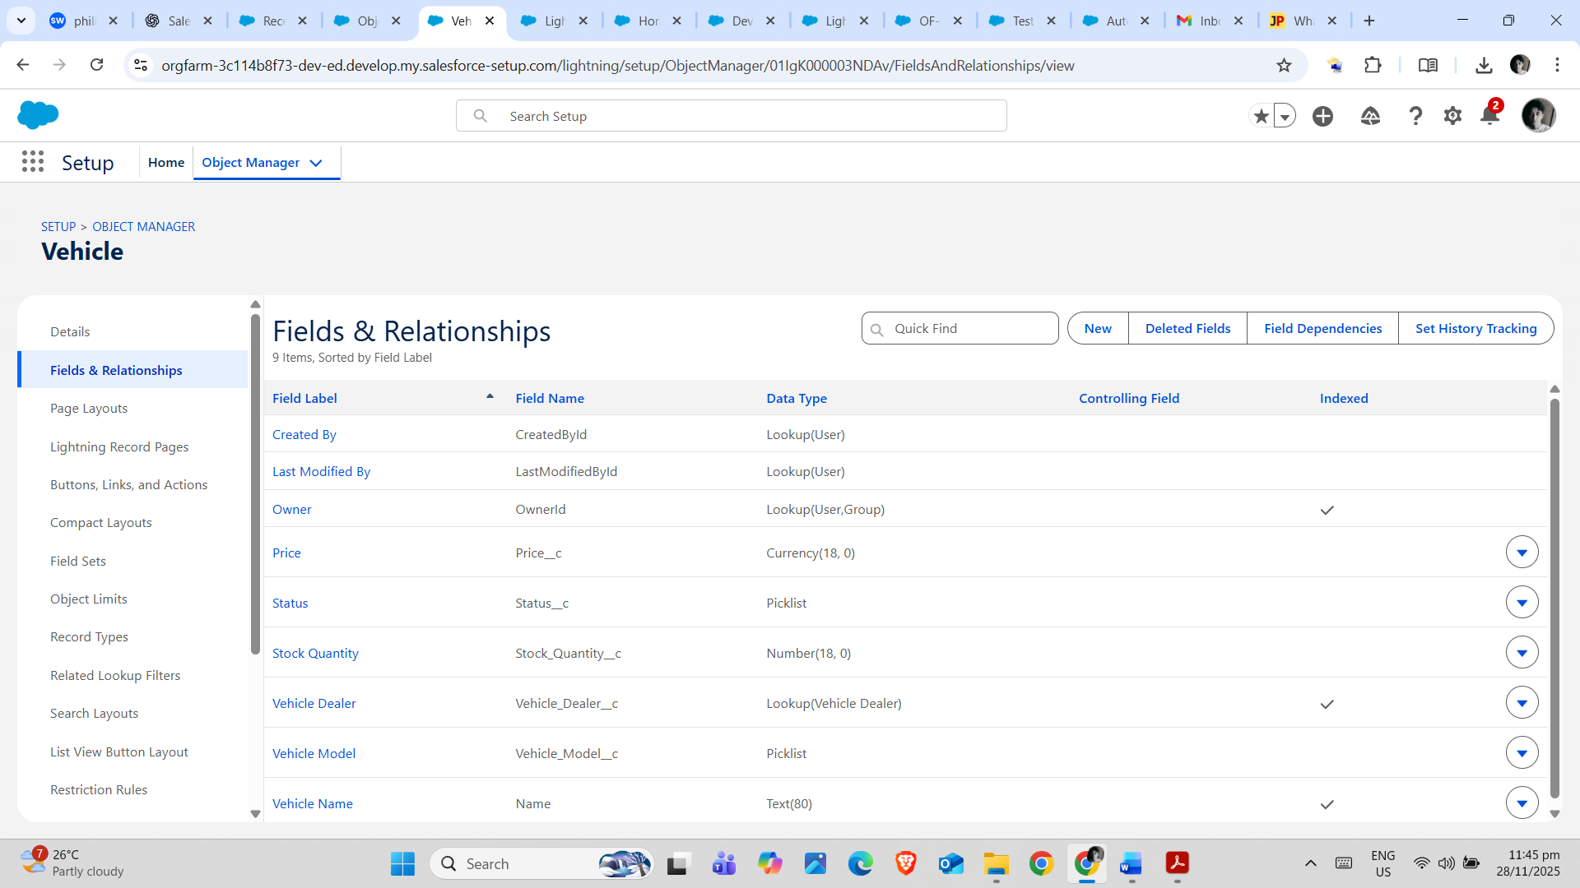
- Vehicle_Dealer__c: Dealer Name, Location, Contact Info
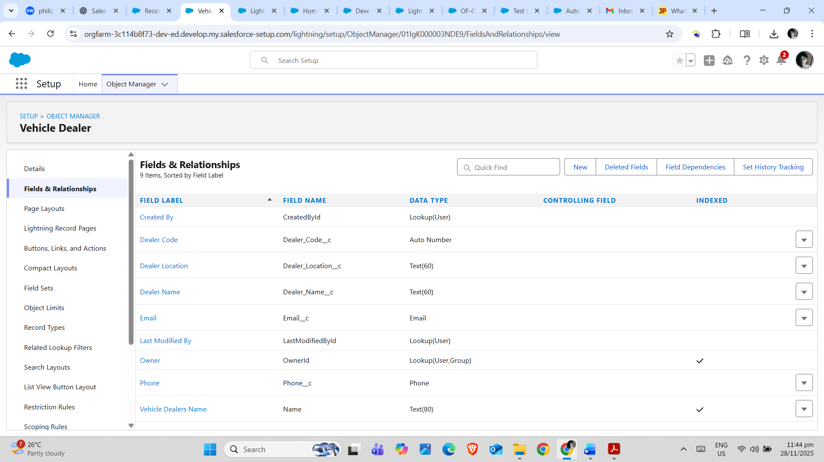
- Vehicle_Customer__c: Customer Name, Contact Info, Email
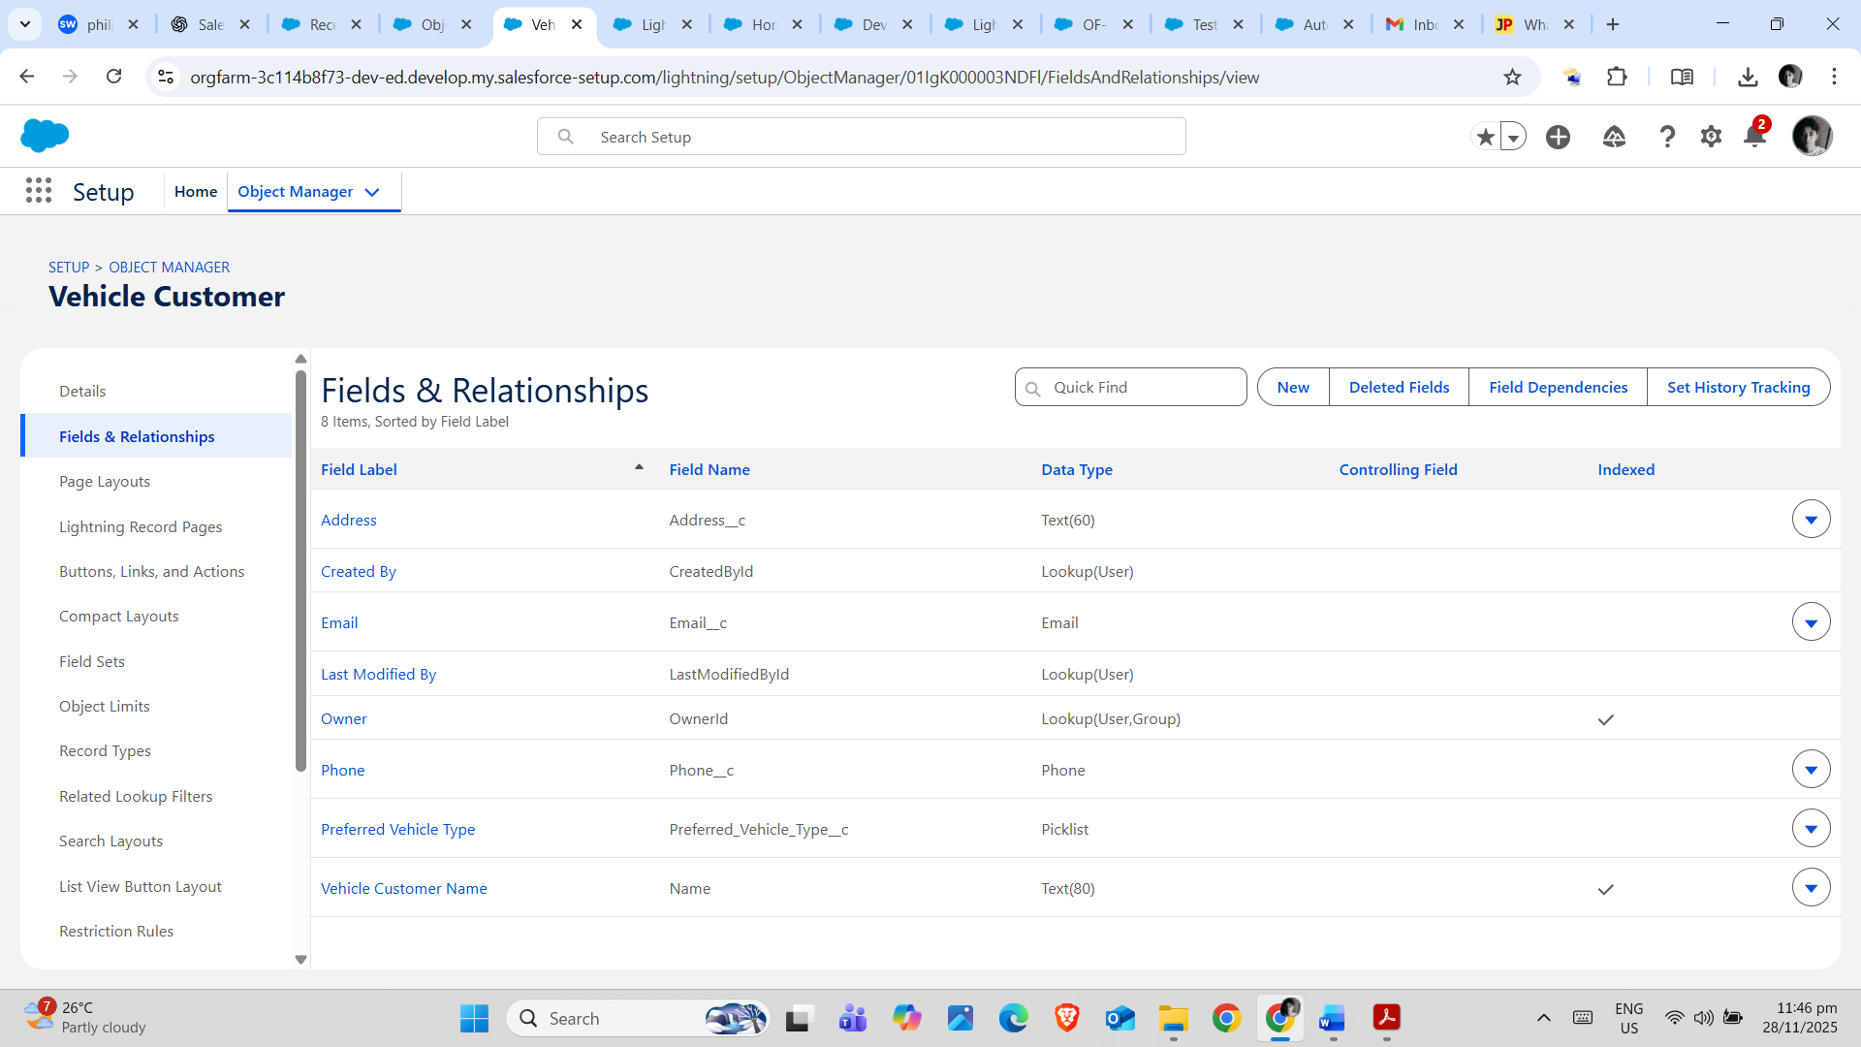
- Vehicle_Order__c: Order Number, Order Date, Related Customer, Related Vehicle
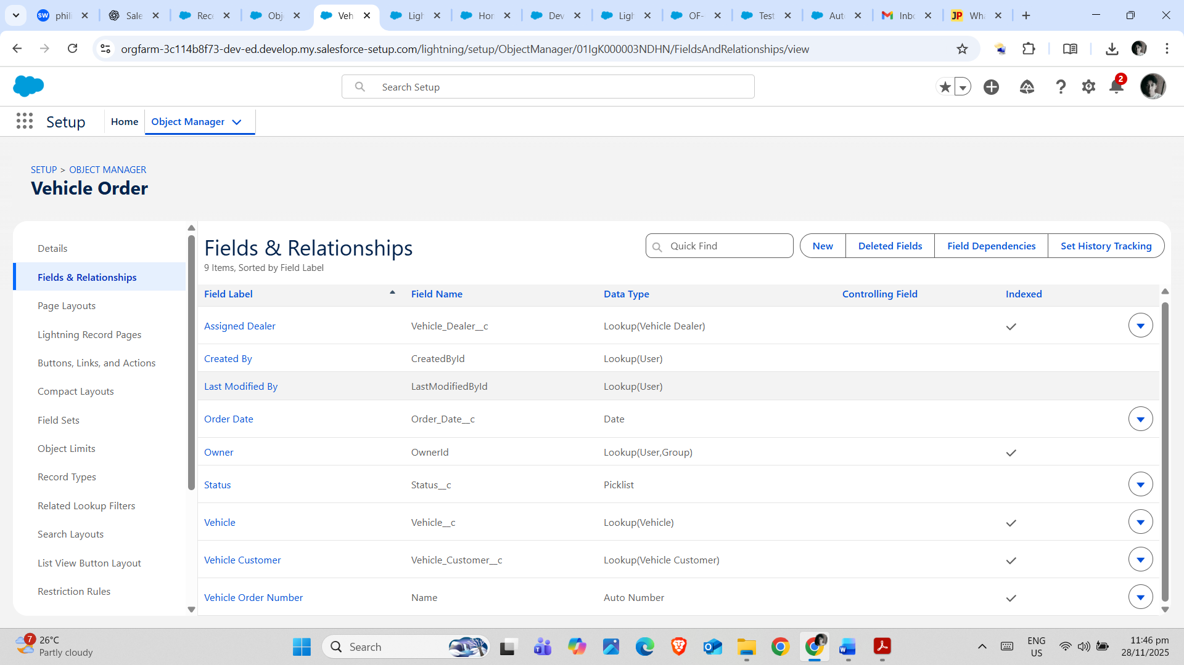
- Vehicle_Test_Drive__c: Test Drive Date, Related Customer, Related Vehicle
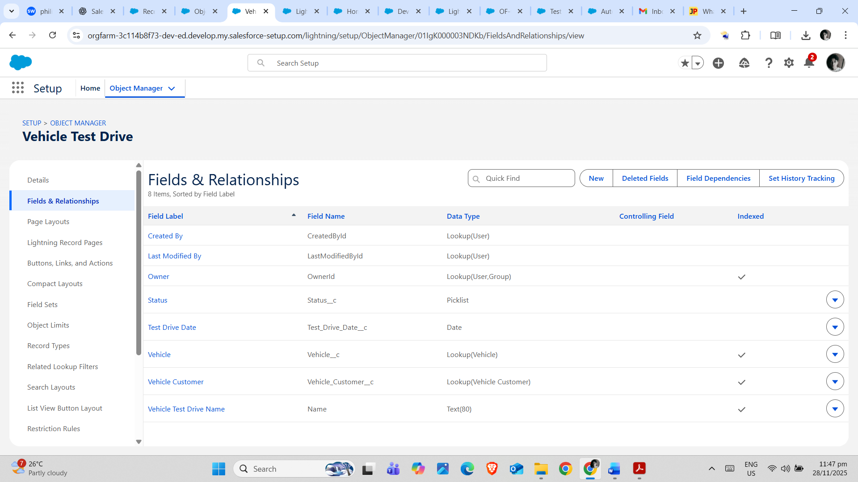
- Vehicle_Service_Request__c: Service Type, Service Date, Related Customer, Related Vehicle
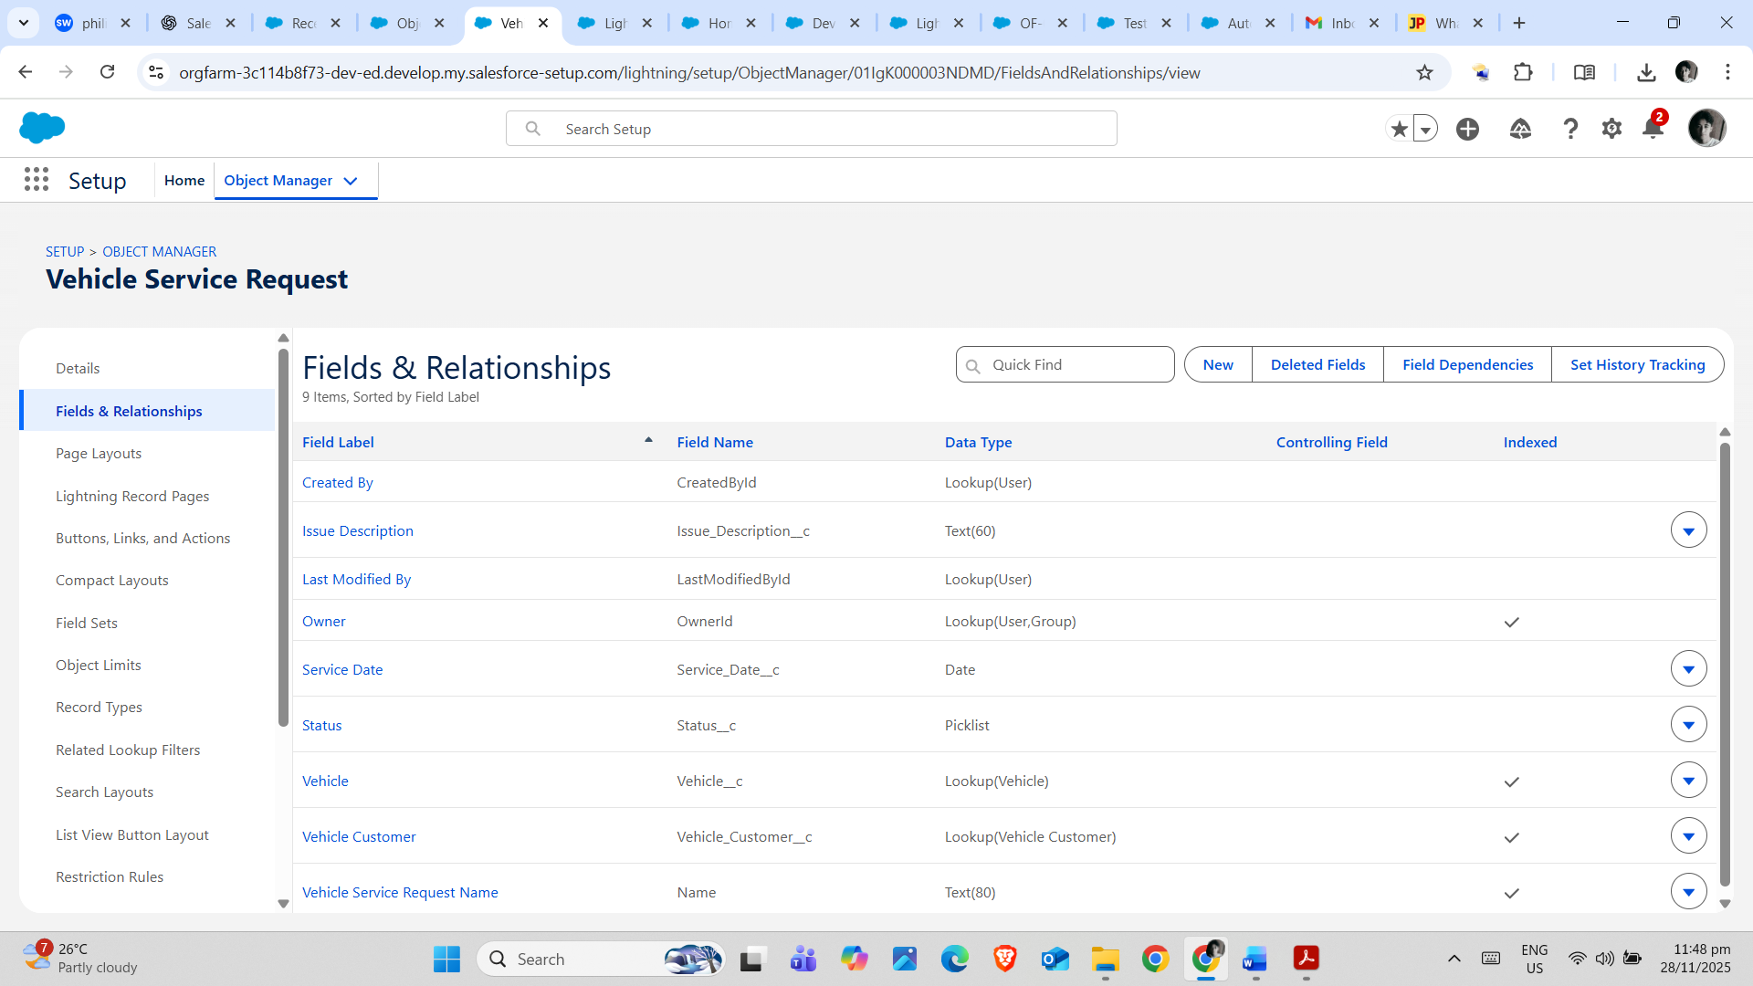
Data Configuration
Validation rules were implemented to ensure accurate data entry:
- Vehicle__c: Price must be greater than zero.
- Vehicle_Order__c: Cannot place order if Vehicle__c is out of stock.
- Vehicle_Test_Drive__c: Test drive date cannot be in the past.
Screenshot: Example of a validation rule applied to Vehicle_Order__c

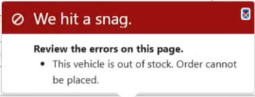
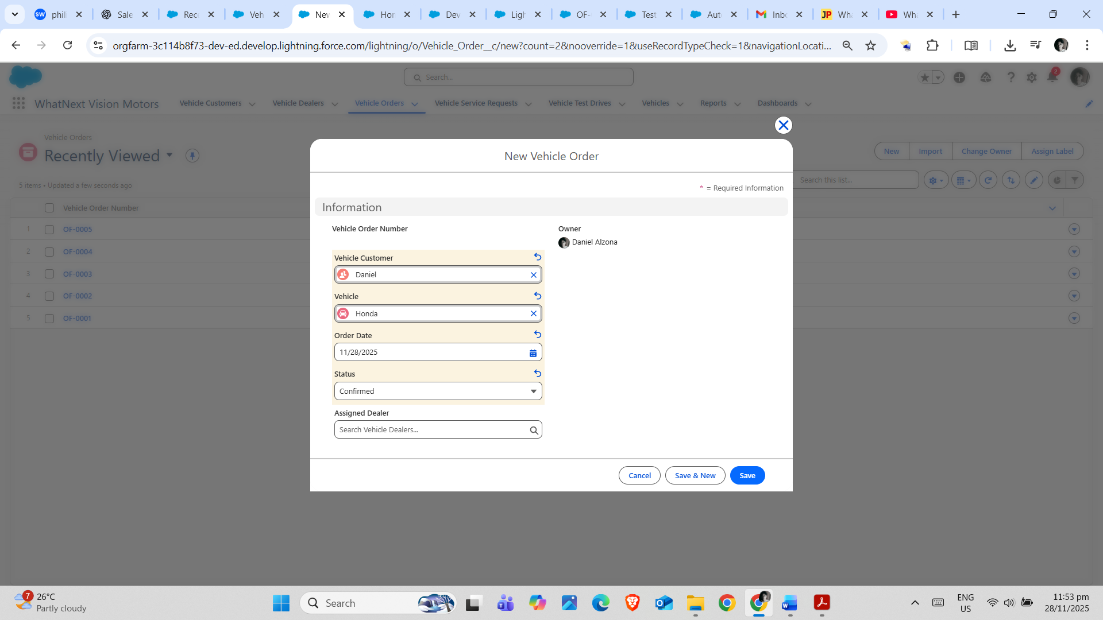

Phase 2: Development
Email Templates & Alerts
- Created Classic Email Templates: Vehicle_Order_Confirmation, Test_Drive_Reminder, Service_Request_Notification.
- Configured Email Alerts linked to Record-Triggered Flows.
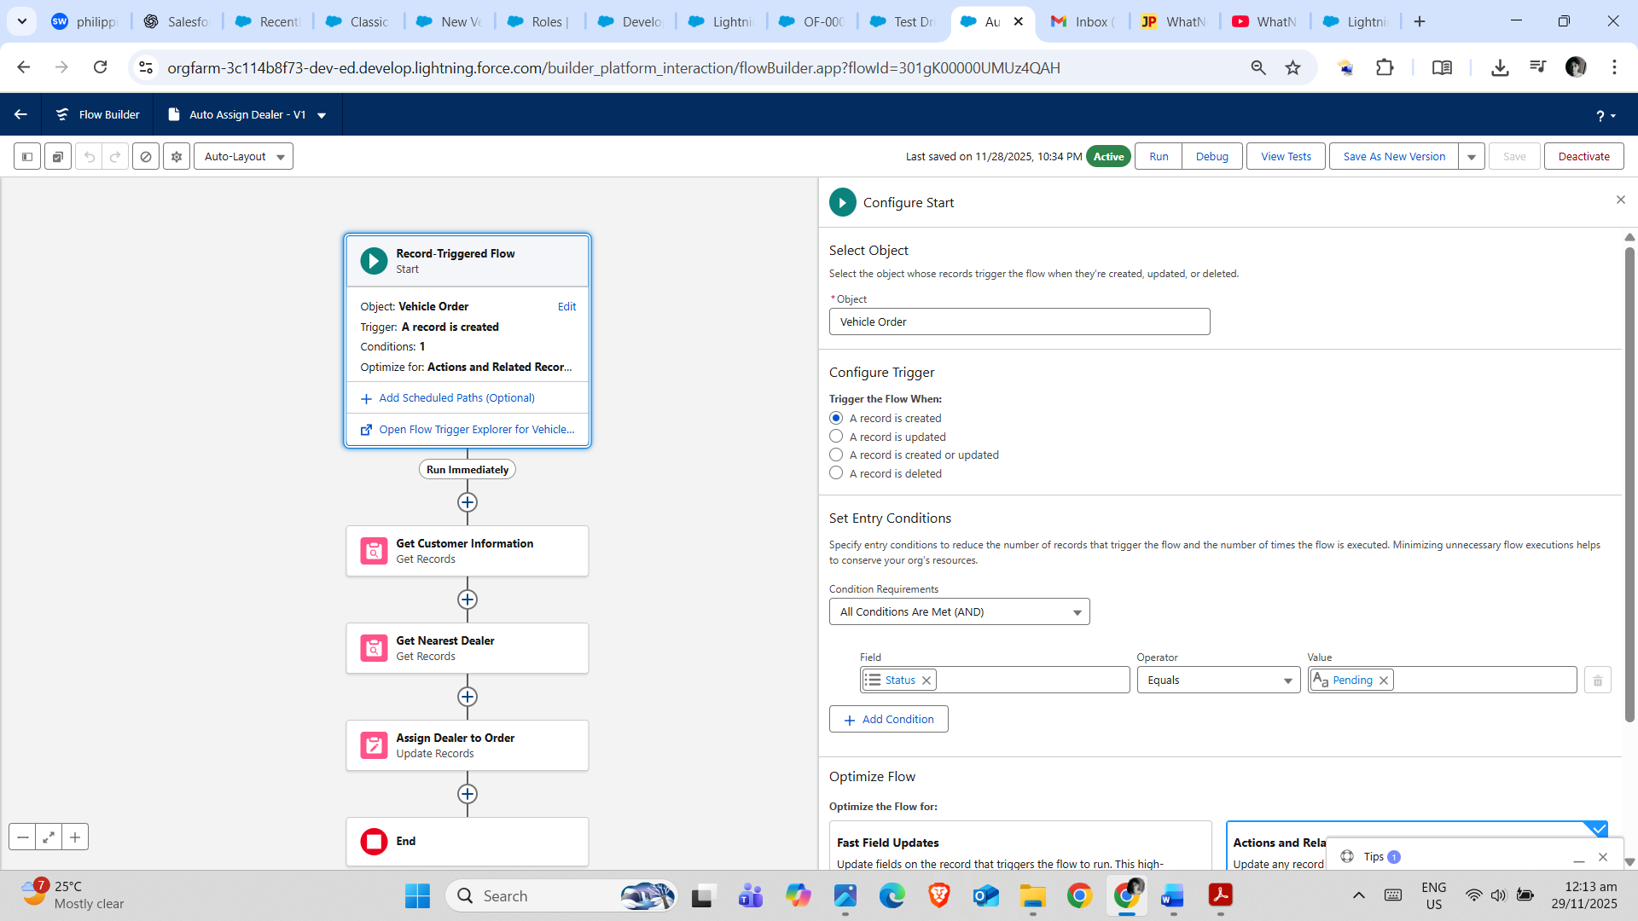
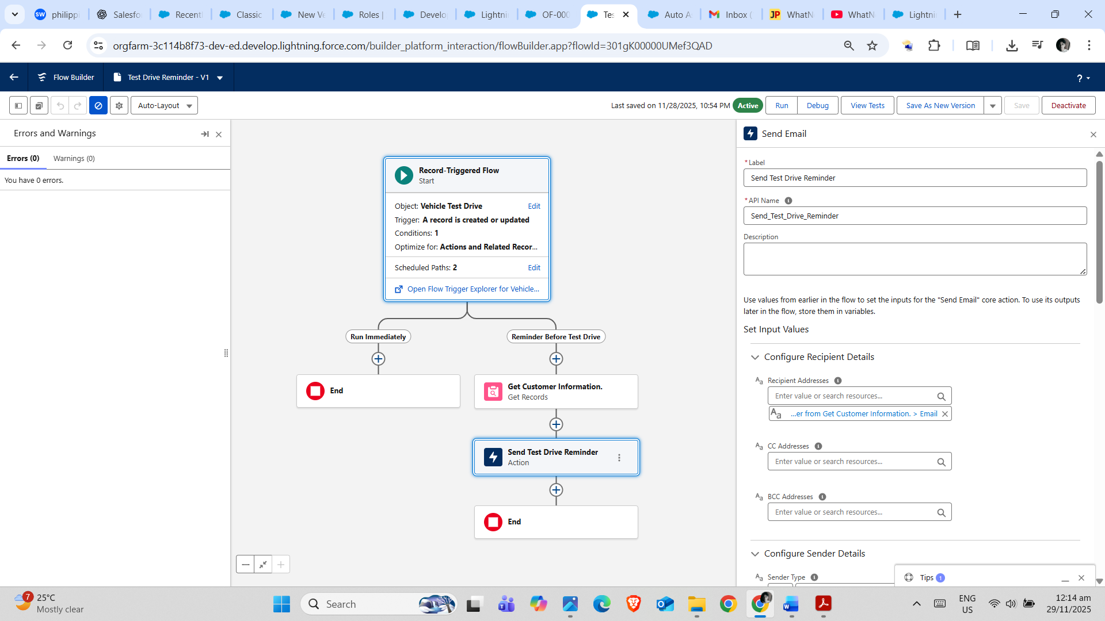
Screenshot: Email template example for Vehicle Order Confirmation
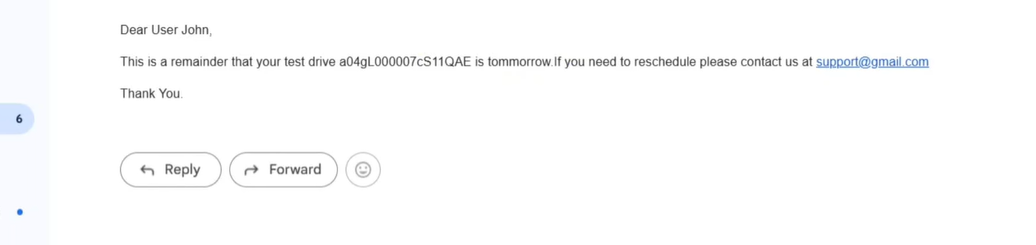
Automation Using Flows & Apex
- Record-Triggered Flows for sending order confirmations, test drive reminders, and service request notifications.
- Apex Triggers:
  - Apex class: VehicleOrderTriggerhandler
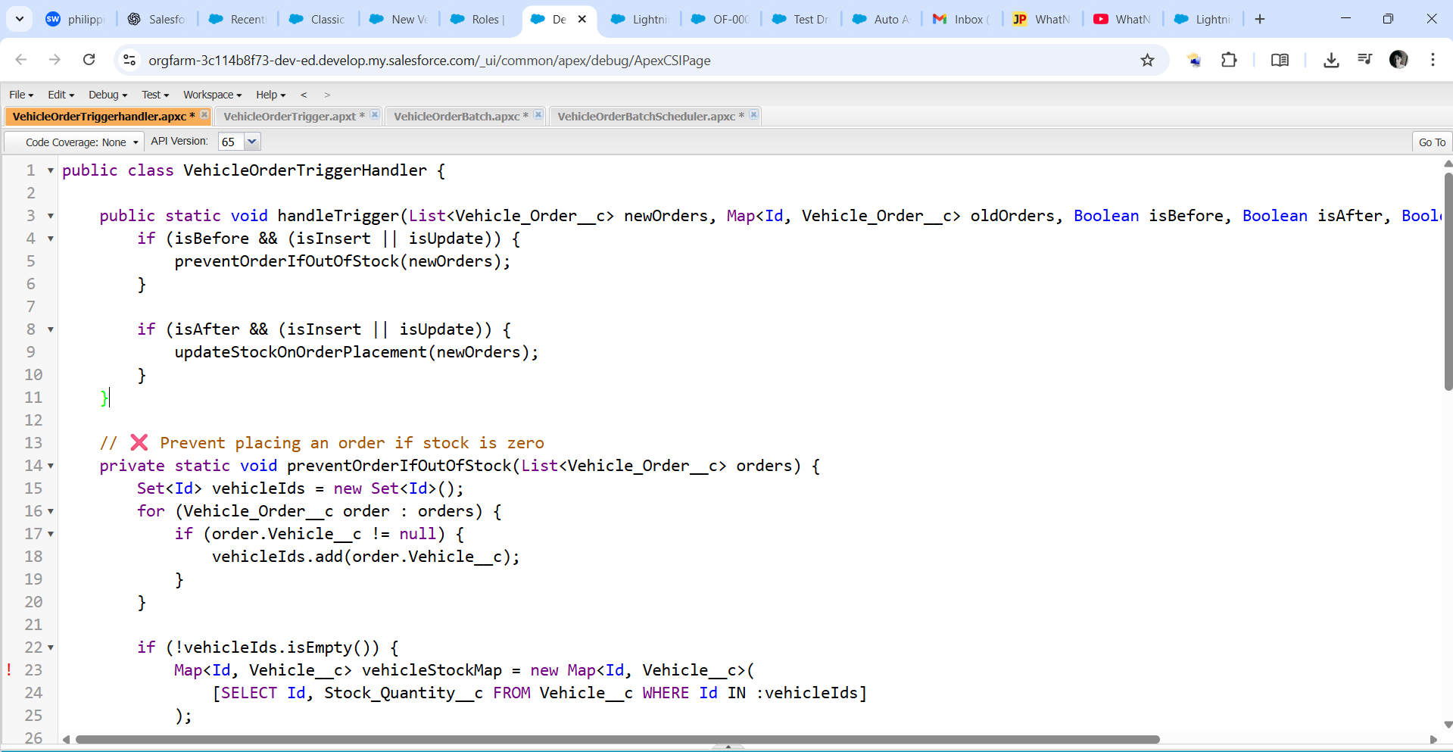
  - Apex trigger: VehicleOrderTrigger
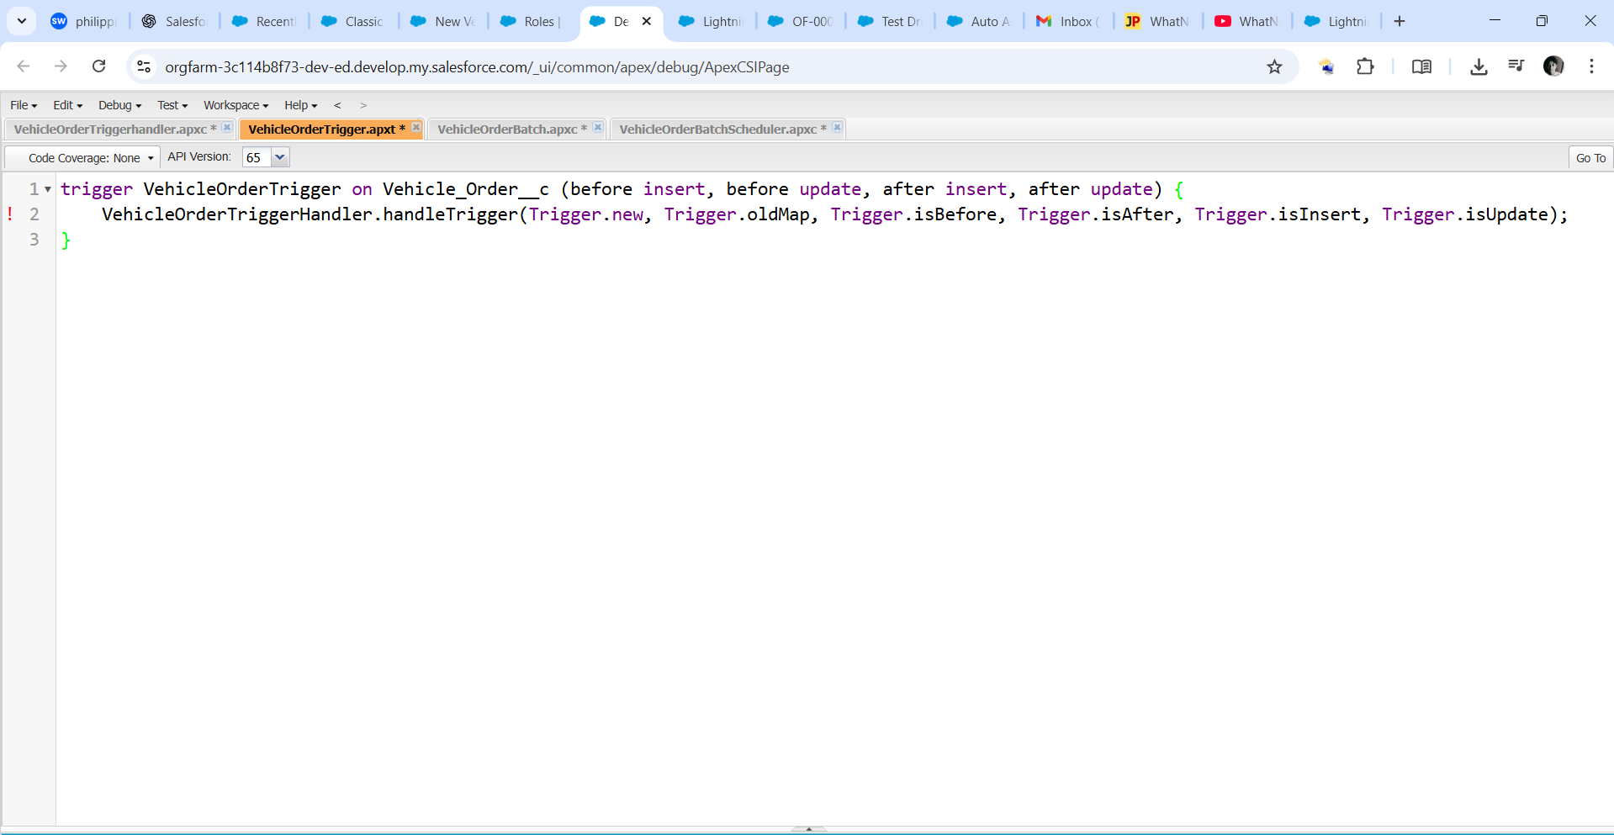
- Batch Apex Class: VehicleBatchJob for updating vehicle availability daily.
  - Apex class: VehicleOrderBatch
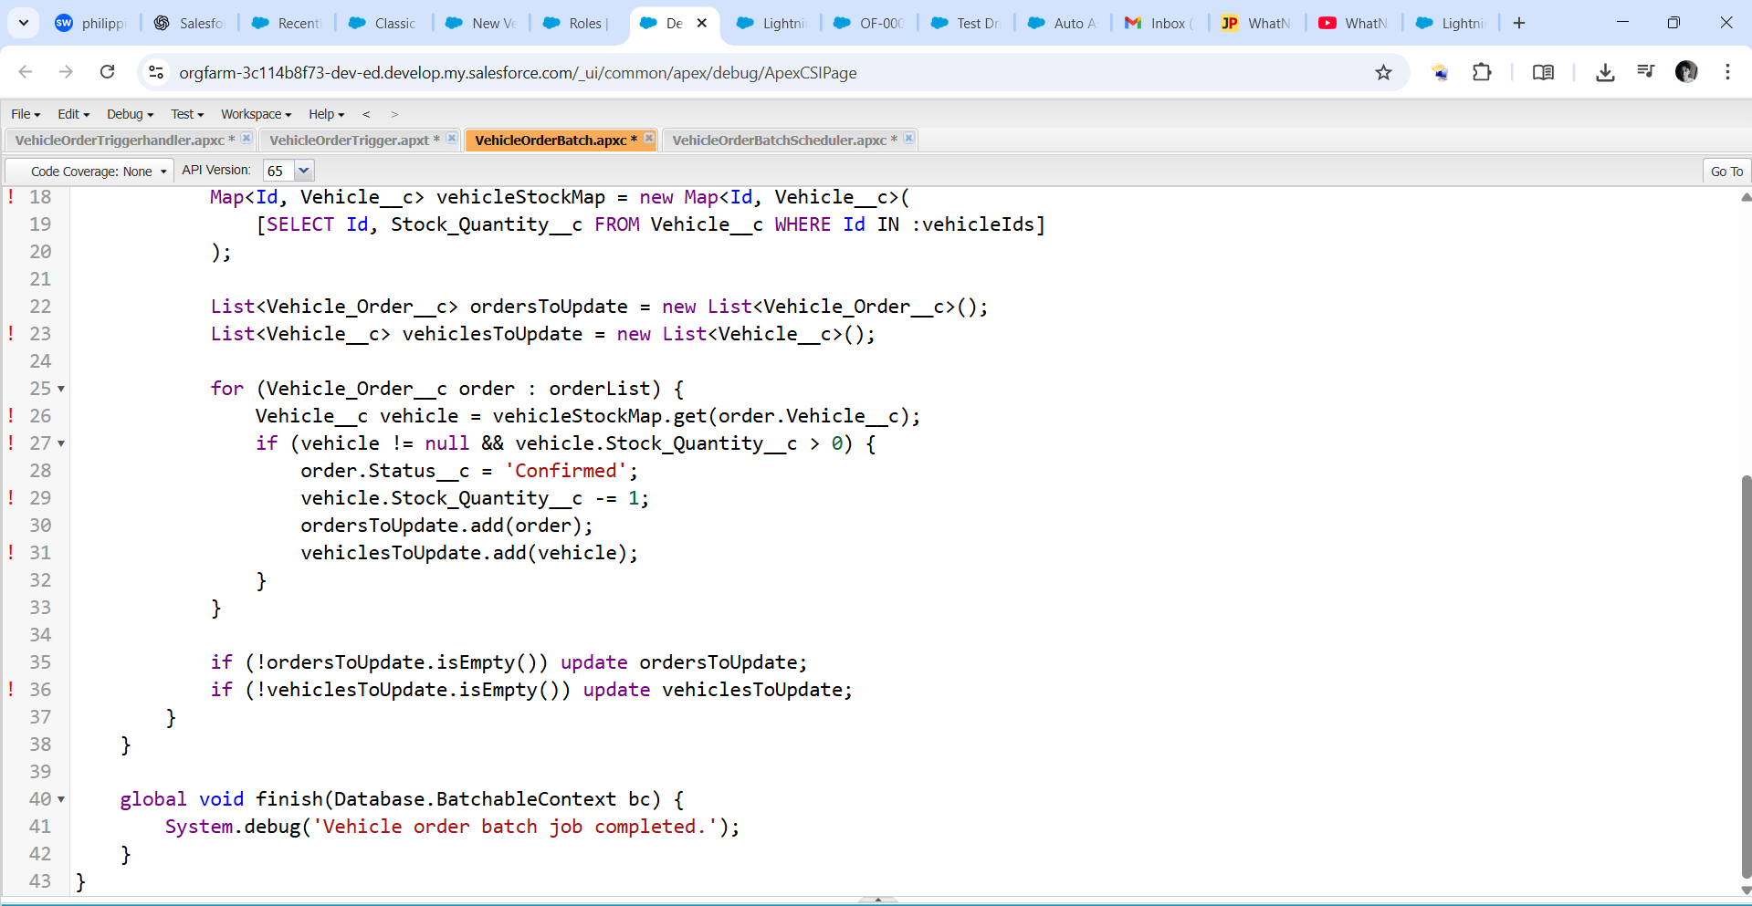
  - Apex class: VehicleOrderBatchScheduler
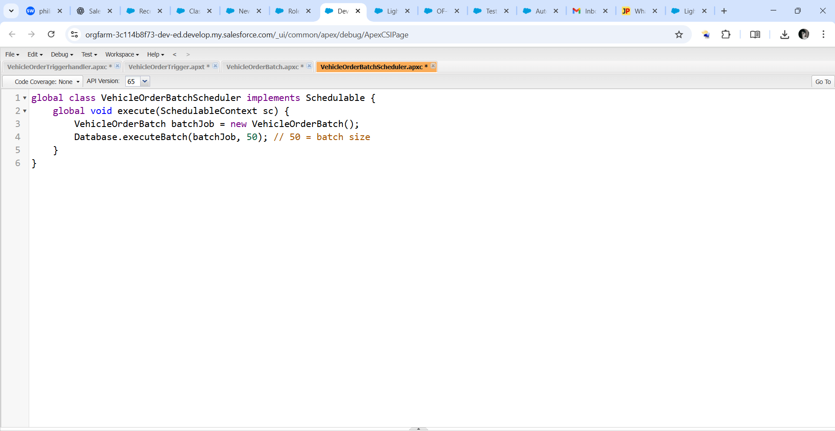

CONCLUSION
The WhatsNext Vision Motors CRM system built on Salesforce successfully streamlines key operations such as vehicle management, order tracking, test drive scheduling, and service request handling. By leveraging Salesforce tools like Custom Objects, Flows, Validation Rules, Email Alerts, and Apex, the system ensures accurate data entry, real-time updates, and improved coordination across departments. Automation minimizes manual errors, enhances productivity, and provides actionable insights for better decision-making in vehicle sales and service execution.

